02/28/2026, Menlo Church Worship, Legacy (last week)

https://www.youtube.com/live/EYP2zTQK3QE?si=L1iGmo0BEvQpljhN

“I Am With You in the Desert | I Am: The God Who Gets Close,” Phil EuBank, Lead Pastor

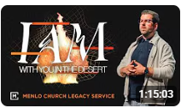

Introduction:

12:00/1:15:02

 

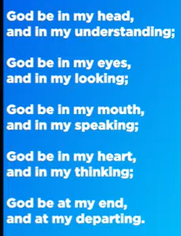

19:00/1:15:02

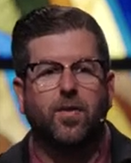 

Phil EuBank, Lead Pastor

We are in the new series of “I Am: Arrival” Series.

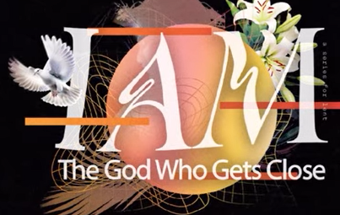

26:00/1:15:02

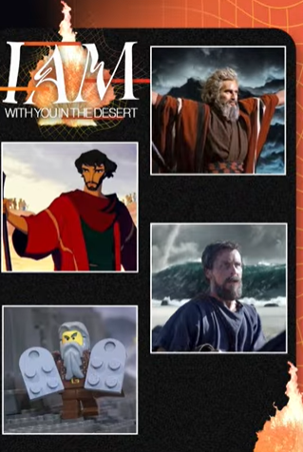

29:00/1:15:02

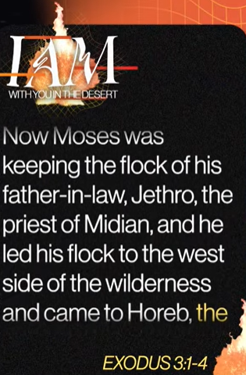 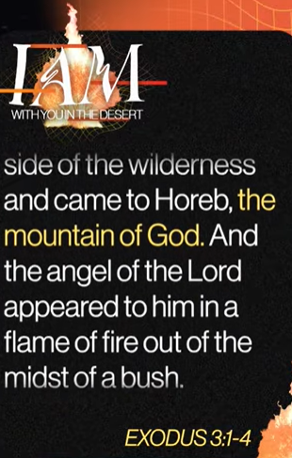 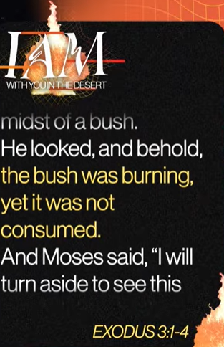

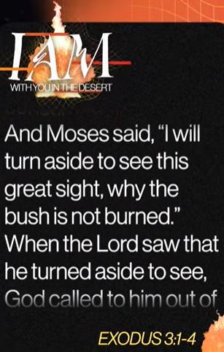 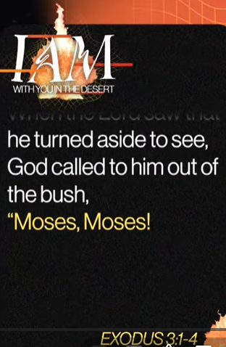

32:00/1:15:02

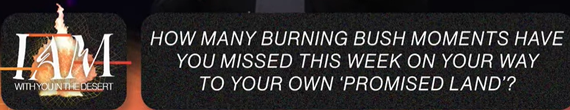

33:00/1:15:02

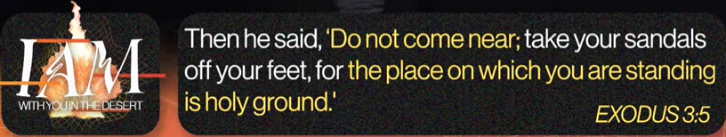

34:00/1:15:02

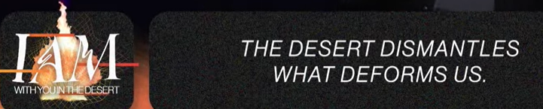

36:00/1:15:02

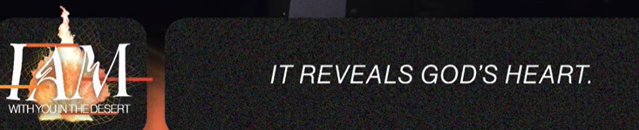

36:19/1:15:02

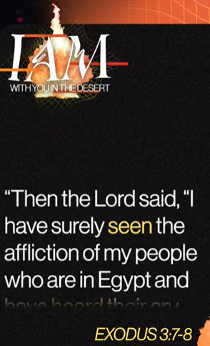 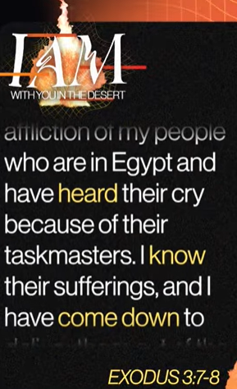 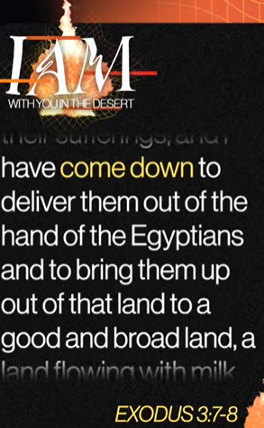

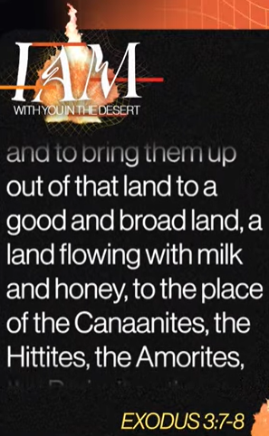 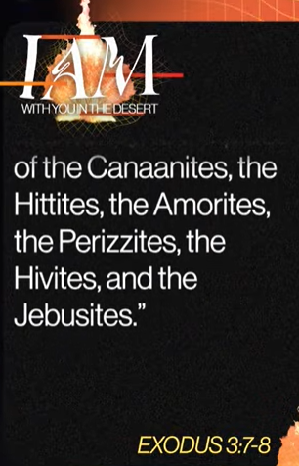

40:00/1:15:02



42:00/1:15:02

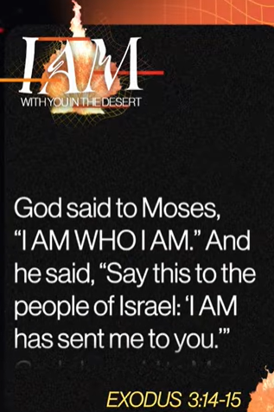 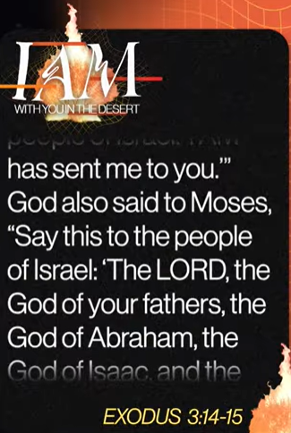

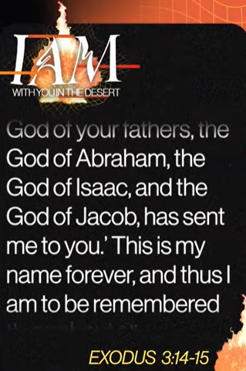 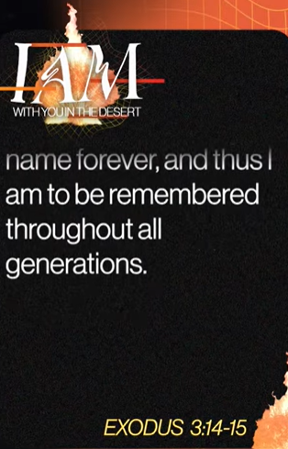

45:00/1:15:02

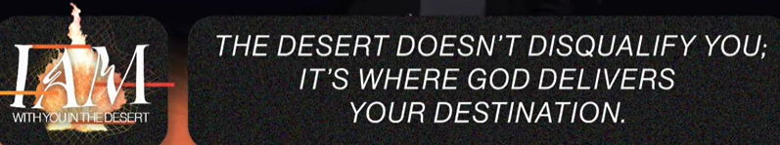

02/28/2026, Menlo Church Worship, Legacy (last week)

https://www.youtube.com/live/EYP2zTQK3QE?si=L1iGmo0BEvQpljhN

“I Am With You in the Desert | I Am: The God Who Gets Close,” Phil EuBank, Lead Pastor

Summary